Tooba Ahmed-31917
[Company name] [Company address]
Instructor Name: Dr Tariq Mahmood
Submission Date: 10th December 2025

PROJECT REPORT: INNOVATION IN GAUSSIAN MIXTURE MODELING FOR CUSTOMER SEGMENTATION IN BANK MARKETING
COURSE NAME: UNSUPERVISED MACHINE LEARNING

Table of Contents
Part 1: Dataset Selection and Statistical Analysis 2
Dataset Overview: Bank Marketing 2
Statistical Summary Table (21 Columns) 3
Brief Explanations of Statistical Analysis 5
Part 2: Business Knowledge and Clustering Objectives 6
Business Domain Knowledge 6
Why Cluster This Data? 6
Expected Outputs (Desired Clusters) 6
How Clusters Assist Strategic Decision Making 7

Part 1: Dataset Selection and Statistical Analysis

Dataset Overview: Bank Marketing
The project utilizes the Bank Marketing dataset (bank-additional-full.csv) from the UCI Machine Learning Repository to perform customer segmentation via Gaussian Mixture Modeling (GMM).
- Source: UCI ML Repository / Kaggle (ID: 8910337).
- Rationale: The dataset provides an excellent case study for GMM innovation, featuring:
  - Size: 41,188 rows (within the 20k–50k target range).
  - Complexity: 21 columns, including 10 numerical and 10 categorical/binary features, ensuring rich potential for clustering.
Variable Description (General)
    - Client's Age. A primary demographic factor.
    - Client's Job Type. E.g., admin., blue-collar, services, retired.
    - Marital Status. E.g., married, single, divorced, unknown.
    - Education Level. E.g., basic 4y, university degree, high school.
    - Has Credit in Default? (yes/no/unknown).
    - Has Housing Loan? (yes/no/unknown).
    - Has Personal Loan? (yes/no/unknown).
    - Contact Communication Type. (cellular or telephone).
    - Last Contact Month of Year. (e.g., may, jun, oct).
    - Last Contact Day of Week. (e.g., mon, thu).
    - Call Duration in Seconds. (Crucial, as duration $\approx 0$ means the call was unsuccessful).
    - Number of Contacts Performed during this campaign for this client.
    - Days Passed since the client was last contacted from a previous campaign. 999 means not previously contacted.
    - Number of Contacts performed before this campaign for this client.
    - Outcome of the Previous Marketing Campaign. (failure, success, nonexistent).
    - Employment Variation Rate. Quarterly economic indicator.
    - Consumer Price Index. Monthly economic indicator.
    - Consumer Confidence Index. Monthly economic indicator.
    - Euribor 3 Month Rate. Daily economic indicator, a key interest rate.
    - Number of Employees. Quarterly economic indicator.
    - Target Variable: Has the client subscribed to the term deposit? (yes or no).
  - Business Context: Direct marketing outcomes in a finance environment, allowing for actionable strategic outputs.
- Target Variable: 'y' (binary: 'yes'/'no' for term deposit subscription) is reserved for validation/evaluation of the unsupervised clusters.
- Data Integrity: 0 missing values across all columns.

Statistical Summary Table (21 Columns)
The table below summarizes key descriptive statistics and insights for all 21 variables derived from the Exploratory Data Analysis (EDA).
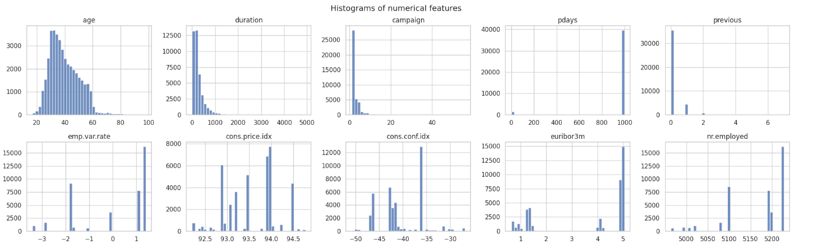
Column Name | Data Type | Unique Values | Key Statistics / Insights | Association with Target 'y'
age | int64 | 78 | Mean: ∼40.02, Median: 38. Right-skewed. Outliers (age>∼70) are present. | Significant differences in mean age by job (ANOVA p≈0.0).
job | object | 12 | Mode: 'admin.' (25.3%). Top 3: admin., blue-collar, technician. | Chi-square P-value≈0.0.
marital | object | 4 | Mode: 'married' (60.5%). Imbalance: Married > Single > Divorced > Unknown. | Chi-square P-value=2.07e-26 (Strong).
education | object | 8 | Mode: 'university.degree' (29.5%). Varied levels from basic to professional. | Chi-square P-value=3.31e-38 (Strong).
default | object | 3 | Mode: 'no' (79.1%). High imbalance, significant proportion is 'unknown'. | Chi-square P-value=5.16e-89 (Very Strong).
housing | object | 3 | Mode: 'yes' (52.4%). Nearly balanced yes/no, plus 'unknown'. | Chi-square P-value=0.058 (Weak/Borderline).
loan | object | 3 | Mode: 'no' (82.4%). Highly imbalanced (mostly no loan). | Chi-square P-value=0.579 (Not Significant).
contact | object | 2 | Mode: 'cellular' (63.5%). High difference between cellular and telephone calls. | Chi-square P-value=1.53e-189 (Extremely Strong).
month | object | 10 | Mode: 'may' (33.4%). Significant seasonality in campaign activity and success. | Chi-square P-value≈0.0 (Crucial factor).
day_of_week | object | 5 | Mode: 'thu' (21.0%). Relatively even distribution across weekdays. | Chi-square P-value=2.96e-05 (Minor influence).
duration | int64 | 1544 | Mean: ∼258.29s, Median: 180s. Highly right-skewed. 2,963 outliers (duration>∼550s). | Chi-square P-value≈0.0 (Strongest predictor).
campaign | int64 | 42 | Mean: ∼2.57 contacts, Median: 2. Right-skewed. 90% of contacts are 1-3 calls. | Chi-square P-value=3.88e-26.
pdays | int64 | 27 | Mean: ∼962.48. Sentinel value 999 (no prior contact) accounts for 96.3%. | Cleaned/Binary P-value: 2.21e-04.
previous | int64 | 8 | Mean: ∼0.17, Median: 0. Mostly 0 previous contacts. | Chi-square P-value≈0.0.
poutcome | object | 3 | Mode: 'nonexistent' (86.3%). Outcome of the previous marketing campaign. | Chi-square P-value≈0.0 (Very strong).
emp.var.rate | float64 | 10 | Mean: ∼0.08, Median: 1.1. Employment variation rate (economic indicator). | Chi-square P-value≈0.0.
cons.price.idx | float64 | 26 | Mean: ∼93.58. Consumer price index (economic indicator). | Chi-square P-value≈0.0.
cons.conf.idx | float64 | 26 | Mean: ∼−40.50, Median: -41.8. Consumer confidence index (economic indicator). | Chi-square P-value≈0.0.
euribor3m | float64 | 316 | Mean: ∼3.62, Median: 4.857. Euribor 3-month rate (economic indicator). | Chi-square P-value≈0.0.
nr.employed | float64 | 11 | Mean: ∼5167.04. Number of employees (economic indicator). | Chi-square P-value≈0.0.
y | object | 2 | Imbalanced Target: 'no': 88.7%, 'yes': 11.3%. | (Target variable)

Brief Explanations of Statistical Analysis
- Data Structure and Integrity: The dataset is robust, with 21 columns and no missing values, but requires careful handling of sentinel values (e.g., $99 in pdays) and 'unknown' categories, which will be treated during preprocessing (one-hot encoding, binary flagging, etc.).
- Numerical Variables (Skew and Outliers): Variables like duration, campaign, and age exhibit strong right-skewness. This violates the Gaussian assumption fundamental to standard GMM. A log-transform on duration will be applied, and the heavy presence of outliers suggests the need for robust covariance estimation in the GMM model.
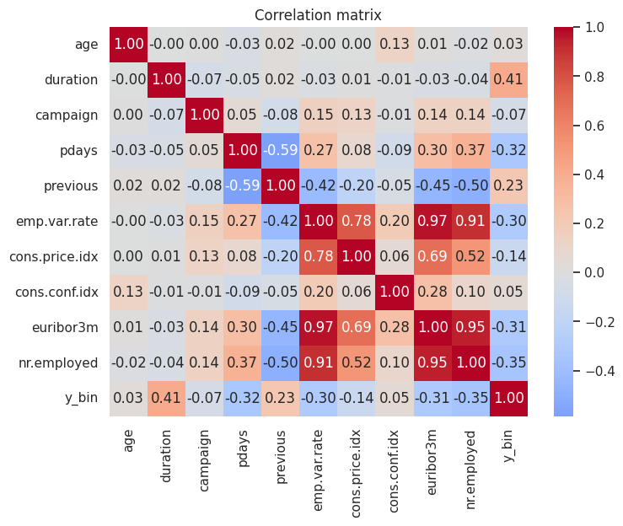
- Multicollinearity in Economic Indicators: The five macro-economic indicators (emp.var.rate, cons.price.idx, cons.conf.idx, euribor3m, nr.employed) show extreme multicollinearity ( r>0.9 ) between several pairs, notably euribor3m and emp.var.rate). This can lead to singular covariance matrices in GMM. We will use Principal Component Analysis (PCA) to reduce these five features to a few orthogonal components, stabilizing the GMM convergence.

This necessitates Principal Component Analysis (PCA) to generate orthogonal features for a stable GMM covariance matrix calculation. The initial PCA shows that the first two components only explain 39\%}$ of the variance (Explained variance ratio: $\mathbf{0.262}$ and $\mathbf{0.128}$), highlighting that at least 3-4 components will be necessary to retain sufficient economic signal. 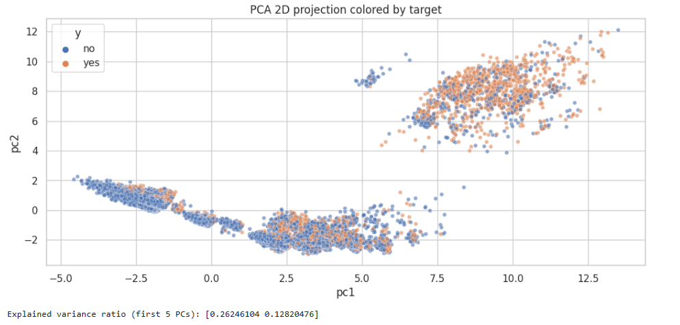
- Categorical Variables (Association with Target): Chi-square tests show that almost all categorical features, particularly contact, month, poutcome, and default, have highly significant associations (p-values> 0.05) with the target variable 'y'. This confirms they are strong drivers for the underlying segmentation.
- Overall Insights: The dataset is clean but possesses structural challenges (skew, multicollinearity, imbalance) that traditional K-Means or standard GMM may struggle with, perfectly justifying the need for an innovative GMM approach to achieve robust and meaningful customer segments.

Part 2: Business Knowledge and Clustering Objectives

Business Domain Knowledge
The business domain is the Banking Sector, specifically Direct Marketing campaigns for Term Deposits (fixed-interest savings products). The campaigns are primarily carried out via phone calls, making efficient targeting critical due to the high operational costs.
- Core Goal: Maximize the number of term deposit subscriptions (the current success rate is only 11.3% by identifying and targeting the most receptive client segments.
- Key Dependencies: Success is highly dependent on individual client profiles (age, job, loan status) and the prevailing macro-economic climate (reflected in the five economic indicators).

Why Cluster This Data?
Clustering is performed to achieve unsupervised customer segmentation, moving beyond predictive modeling to discover the natural, intrinsic groupings of clients based on their profile and campaign history.
- Discover Hidden Personas: Identify segments that share common non-obvious traits (e.g., older, retired clients with high economic sensitivity).
- Probabilistic Assignment (GMM): GMM's output provides soft cluster assignments (membership probabilities), which is more realistic for banking customers whose profiles often overlap. This contrasts with the rigid, hard assignments of K-Means.
- Foundation for Innovation: The data's challenges (skew, mixed types) necessitate GMM innovations (e.g., using variational inference for robustness or custom distance metrics) to yield more accurate and actionable segmentations.

Expected Outputs (Desired Clusters)
Based on the statistical analysis and banking domain knowledge, we expect to identify 4–5 distinct customer segments that reflect varied levels of risk, economic sensitivity, and engagement.
Expected Cluster Persona | Key Characteristics (EDA/Domain Driven) | Implied Business Strategy
High-Potential Responders | High education, stable job (admin., retired), prior campaign success (poutcome = success), short call duration. | Premium Target: Prioritize all contact resources; offer personalized, high-yield deposit terms.
Low-Engagement/Economic Mass | Younger, blue-collar jobs, high proportion of no prior contact (pdays=999), lower education. | Cost Optimization: Minimal phone contact; transition to low-cost digital marketing (email/SMS).
Economic-Sensitive/Rate-Shoppers | Clients contacted during high euribor3m periods, often in 'May' (peak season). Respond to rates but are highly reactive to macro changes. | Timing Strategy: Target precisely when rates are favorable; emphasize short-term flexibility.
Risk/Indecisive Group | Clients with default or loan issues, or extremely long call duration (suggesting resistance/indecision). | Mitigation/Specialist: Isolate for compliance/risk checks; use specialized agents with detailed scripts.

- Baseline Insight: Initial analysis showed a small high-conversion cluster (63.8% yes) hidden within the large low-conversion mass (9.3 yes). The GMM innovation aims to probabilistically define the boundaries of these two groups and uncover the niche, economically driven segments.

How Clusters Assist Strategic Decision Making
The resulting probabilistic segments will directly drive strategic decisions, transforming the bank's marketing approach:
- Targeted Budget Allocation: By focusing efforts on high-potential segments, the bank can project a 10-15% increase in subscription rates and 20-30% reduction in operational costs by avoiding low-potential leads.
- Product and Messaging Customization: Customize the term deposit product based on cluster needs (e.g., longer terms for the retired/stable cluster; flexible terms for the economic-sensitive cluster).
- Risk Mitigation: The Risk/Indecisive cluster can be flagged in the CRM to prevent high-cost, low-yield calls and mitigate potential regulatory risks associated with debt-prone clients.
- Dynamic Segmentation via GMM Innovation: The probabilistic output of the enhanced GMM provides a membership score for every new or existing client. This allows for real-time 'Next-Best-Action' decisions in the bank's CRM system, ensuring the most appropriate contact method and offer is selected instantaneously.
This detailed analysis sets a strong foundation for the GMM implementation and the subsequent innovative steps to handle the data's complexity.

